Walk 11 Stretton Grandison
Last walked in December 2018

Distance. A 6 km (3.7 miles) easy walk across farm land.
Start. St Lawrence’s church. Explorer Map 202 Grid 633441.
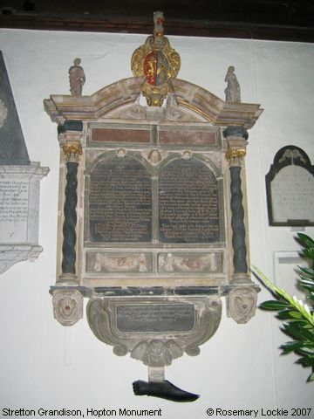
Directions from Whitecross Roundabout. [Turn milometer to zero]. Take the A4110 Canon Pyon (Three Elms road). After 1 mile, at traffic lights, TR onto the Roman Road and the A4103 to Worcester. After 10.1 miles, at traffic lights, TR onto the A417 to Gloucester. At 11.3 miles you TL, and 100m further on TL again to park by Stretton Grandison church.

1. Church of St Lawrence. St Lawrence Church dates back to the 13th Century and over the century’s the parishioners have strived to maintain the Church and its Traditions. Inside the church are beautiful stained glass windows; the only hexagonal font in Herefordshire that has a sunken quatrefoil on each face, the font has been painted a reddish colour. There is also a monument to Sir Edward Hopton, died in 1668 and his wife Deborah, died in 1702. Figures of Hope and Charity grace the pediment, and a genuine gauntlet from the Civil War hangs from beneath it. Walk into the churchyard and TL in front of church spire, then carry on up the straight path and over a stile into a field F1. Bear R and go up the field to go thru a small wooden gate into a strip of trees. Continue in the same direction to back out of the trees into F2 going thru a second small wooden gate. TR and walk along the edge of the field, (the wood is on your R), at the end of F2 you go thru a small wooden gate into F3, and continue along the field edge keeping the wood on your R. Continue on, and at the end of this field you go thru a metal gate that stands between two cottages. Continue on along a gravel drive to cross over a cattle grid onto a road.
Sir Hopton’s monument

2. Cattle Grid. TR, go down the road, about 100m beyond a black and white cottage on the L you TL and walk along the signed surfaced bridle path/road. At the cross roads (the New House private road is in front), you TR and continue on for about 80m. TL off the surfaced path and go thru a small, way marked metal gate and into F4, walk along the L edge of this large arable field. In the bottom L hand corner you go thru a small metal gate and into F5. Heading in the same direction, towards a pylon, go along the L edge of this field and thru a gap in a hedge into F6. Continue along the L edge of this field, towards the pylon, to cross a footbridge into F7. Bearing R (one o'clock) you go across this field to walk over the second footbridge into F8. Favour the L edge of this arable field as you head for the trees. At the end of the field you follow the edge around to the R, and 30m on you TL into the trees and continue along a small dirt track to cross the river Frome via the third footbridge. Exit the trees by crossing a plank bridge and small wooden gate into F9. Walk along the L edge of this large field. Continue around this field to go thru a metal gate in top R corner and onto the main road, (Mill Cottage sign is displayed).

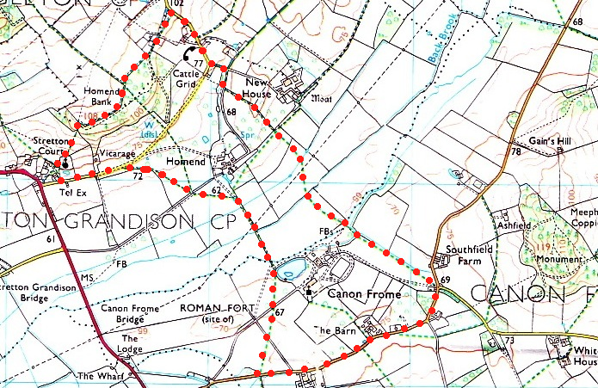
3. Mill Cottage. TR and walk along the road for about a kilometre, passing ‘Rochester House’ (former vicarage then club), ‘Forge Courtyard’ and then ‘The Staples’. Further on, at the beginning of a small wood (R), you TR and cross over a stile into F10. Bear half R and cut across this large field, onto a tarmac lane that goes to Canon Frome:St James church, (ignore a concrete path if you happen to cross over it). A Roman auxiliary fort, (look at map) lay to the west of Canon Frome and covered an area of just over 5 acres, the area available for occupation was about 4¾ acres, the fort was protected by a rampart and double ditch system. The encampment would have been large enough to have been garrisoned by a mixed auxiliary unit of both foot soldiers and cavalry troopers with a nominal complement of five hundred men. The unit was probably stationed during the early campaigns of governor Publius Ostorius Scapula, sometime around A.D.47/8. TR and walk along the lane to reach the gate into Canon Frome Court and the church. Don’t go thru the gate, but TL and walk along the R edge of F11, to go thru a metal gate in the far R hand corner.
2
1

4. Field Corner. Now go ahead thru gap and continue on along the L edge of F12. Cross over a ditch into F13 and continue along the R hand edge, to cross over a concreted double gated bridge and into F14. Very slightly L you then continue on for about 80m and go thru a kissing gate into F15. Bear L to go straight across this field and thru a gated gap, which is about 130m in from the R hand corner (or follow the R edge of the field around) to cross over a low concrete bridge into F16. Go straight across this field to go thru a kissing gate into common ground. Carry on in the same direction to reach an unfenced road. TL and head back to the start point.
3
4

